Task 1:

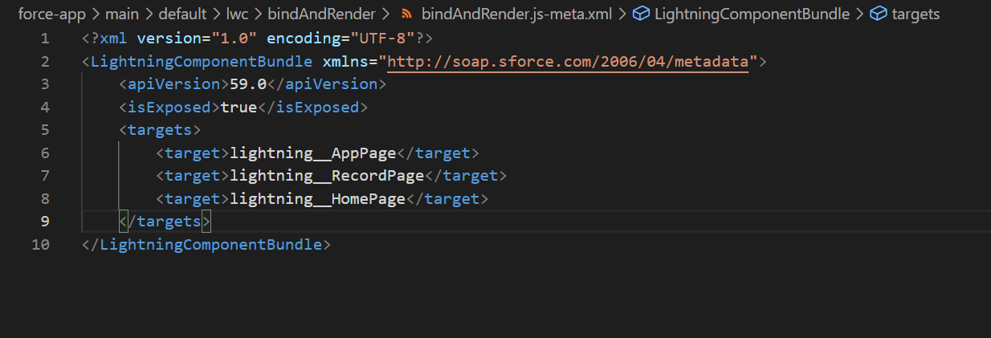

Task 2:

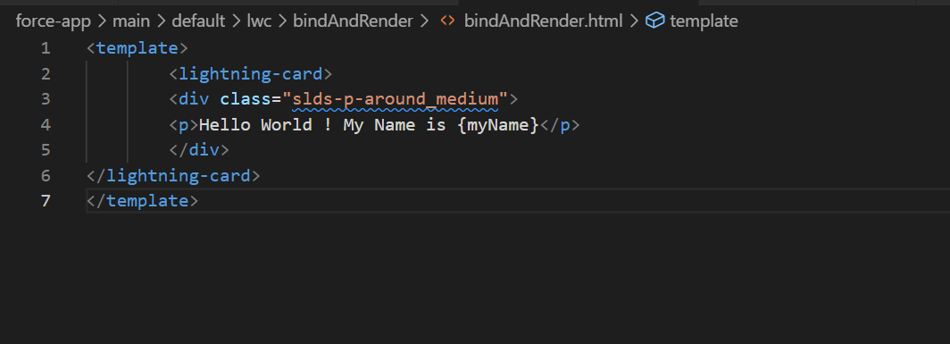

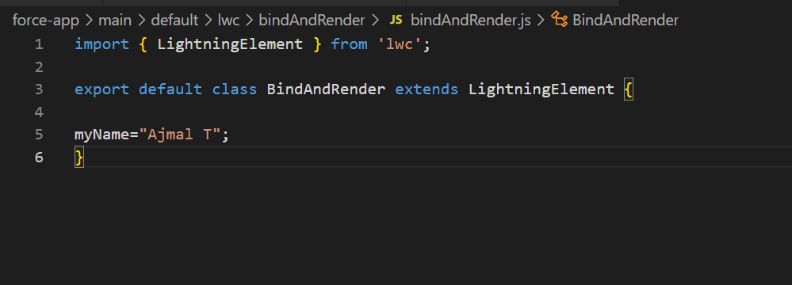

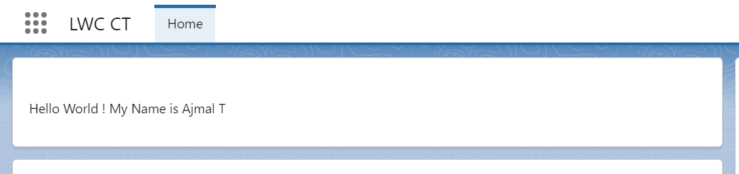

Task 3:

HTML;

<template>

<lightning-card>

<div class="slds-p-around_medium">

<lightning-input type="checkbox" label="Display Content" checked={Checked} onchange={handleCheckBoxChange}></lightning-input>

<template if:true={Checked}>

<p>Hello World ! My Name is {myName}</p>

</template>

</div>

</lightning-card>

</template>

JS;

import { LightningElement } from 'lwc';

export default class BindAndRender extends LightningElement {

myName="Ajmal T";

Checked = false;

handleCheckBoxChange(event) {

this.Checked = event.target.checked;

}

}

1.  
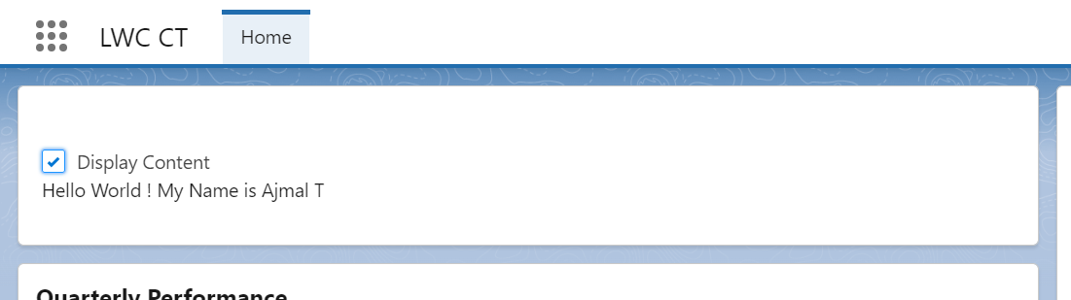

2.  
